Module 7 Final Project

Darrin Pohlman

The objective of this project is to determine the impact of the COVID-19 pandemic on anxiety and depression disorders from survey participants across the United States. This project analyzed survey results throughout multiple timeframes and correlated increases and decreases in response values to key throughout the pandemic. This project also analyzes the demographic differences in survey results during the top ten highest and bottom ten lowest stress timeframes. The first section, the executive summary, of this document will highlight a dashboard that was created to describe this comparison of anxiety and depression disorder indicators with the high and low-stress timeframes of the pandemic. The middle section of this document will further drill into demographic differences and their implications for the survey results. The final section will provide a more detailed explanation of my analysis process, the challenges that needed to be overcome, and new insights gained by this project.

**Executive Summary**

The COVID-19 pandemic had a direct influence on anxiety and depression disorders across the United States. The dashboard below illustrates the increase and decrease in indicators for anxiety and depression collected through surveys targeting a diverse representation of citizens. The increase and decrease in indications closely align with milestones encountered throughout the pandemic.

The lower half of this dashboard highlights the differences in survey results by demographic attributes during the most and least stressful time periods.

During the top 10 survey periods with the highest anxiety and depression indications captured, it was interesting to learn that participants in Nevada, Louisiana, and Mississippi experienced higher indications than other states. The survey also identified the youngest participants with less than a high school education and races other than Asian or White experienced the highest indicators for anxiety and depression.

During the bottom 10 survey periods with the lower levels of anxiety and depression results, the demographics changed with regard to who was most stressed. Within these surveys, Oklahoma, West Virginia, and Louisiana were most impacted. Survey subjects between 30 and 49 years of age, with a Bachelor’s degree or higher, and not Asian or Hispanic experienced the highest indicators for anxiety and depression.

These results demonstrate that COVID-19 impacted the anxiety and depression indicators across all demographics at different levels during various timeframes of the pandemic.

**Analysis Focused on Stress Impact by Demographic Groups**

In order to understand the demographic nuances of the survey results, several charts were created to tell a story of which demographic attributes had the greatest influence on anxiety and depression indicators. Education, Race, Sex, and Age differences contributed to the variation in survey results.

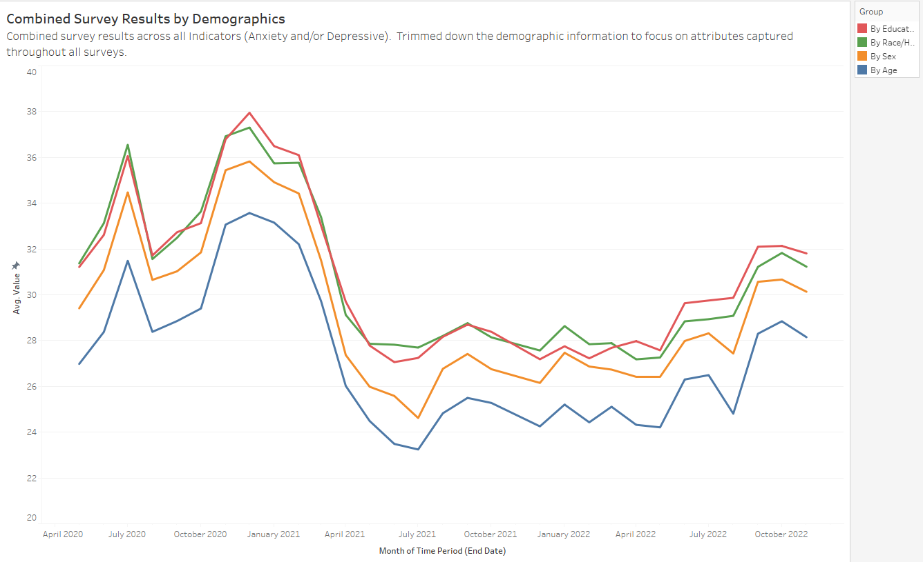

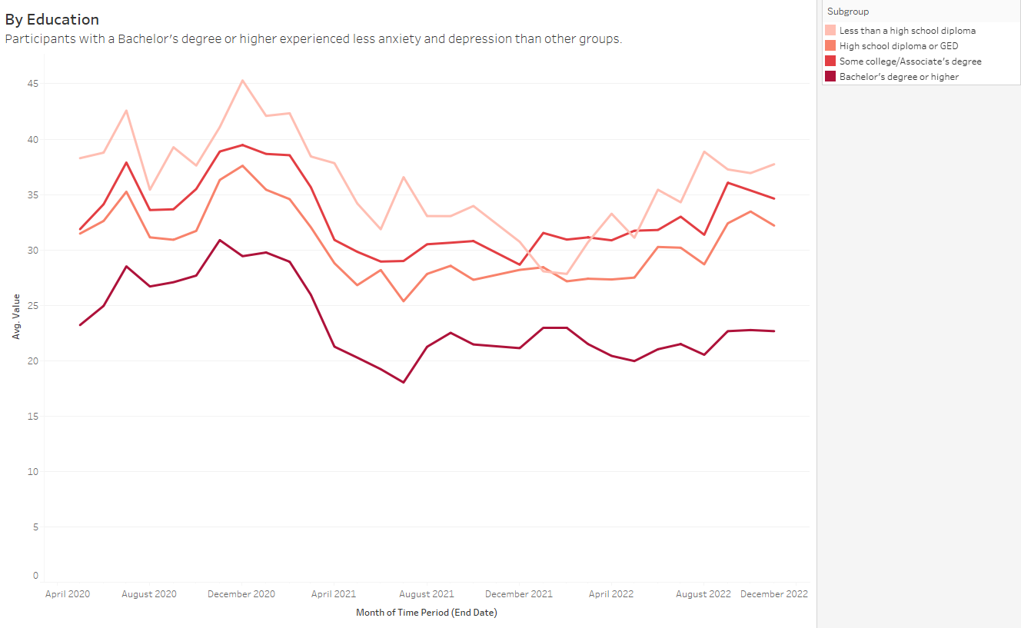

New demographics captured in surveys after August 2021 demonstrate that Transgender participants and individuals With a Disability provided responses with higher indications for anxiety and depression disorders compared to other participants in the subdomain. Each of these charts illustrates the variations that make us unique and can also influence our anxiety and depression thresholds.

**A detailed explanation of the Analysis Process**

The data source that I selected for the final project is focused on Indicators of Anxiety or Depression deriving from the Household Pulse Survey which was conducted to measure the impacts of COVID-19 pandemic on employment status, consumer spending, food security, housing, education, and physical/mental wellness. I found this data source on the Data.gov website and was curious to analyze the survey results based on each geography, demographic, and timeframe of the survey.

Data file: <https://data.cdc.gov/api/views/8pt5-q6wp/rows.csv?accessType=DOWNLOAD>

Before analyzing the data, I wanted to see if survey results were different by state or US region. I also wanted to see if there is a trend of data results up or down during the specific periods when the survey was conducted. Finally, I wanted to analyze if anxiety/depression indicators during this period are more impacted by age, gender, ethnicity, education levels, or other demographic attributes.

I experienced a few challenges with data quality from Household Pulse Survey responses. In analyzing the data set, I needed to resolve some data overloading and incompleteness issues. The state column included a value “United States” for several of the observations. These observations were filtered from the state-by-state analysis. There were also a few null values found in the results that were filtered from all the analyses. The demographic information for each survey is derived from a combination of the Group and Subgroup table columns. The survey data extended their demographic information after August 2021 to capture additional attributes focused on disability, gender identification, and sexual orientation. Analysis of survey results for these specific demographic attributes could only be used late in the COVID pandemic timeframe (post-August 2021). Finally, the multiple time attributes in the data set required some understanding and a decision to drive consistency across charts. The Time Period attribute provides a unique identifier for each survey period. Time Period Start Date and Time Period End Date can be used to find the specific timeframe for each period. The Phase column is not useful as it included overloaded values and inconsistencies in data numbering. For consistency across charts, I decided to leverage the Time Period End Date for each survey period.

Here is an early chart that was created illustrating the new demographic attributes being added in the summer of 2021. After further analysis of demographic differences, this chart was discarded.

The chart is admittedly too busy and takes the reader into too many different attention areas. I had to separate the new demographic attributes and drill down into reporting that applies to surveys conducted after August 2021. Here is a chart representing the differences in survey values based on the incremental demographic attributes captured in late 2021.

I also needed to further analyze the variation of responses by indicator as the data file differentiated responses with indications for Anxiety Disorders, indications for Depression Disorders, and a combination of either Anxiety or Depression Disorders. This led to an additional resource and a caption to rationalize why I was combining the results for all three indicators when analyzing demographics.

The following chart focused on the top periods only confused the matter further and was discarded.

Finally, I found this project to be very engaging as I have seen how the COVID pandemic has impacted many families in different ways and at different times of stress. While mapping key COVID milestones to the emotional highs and lows, I recalled many challenges that I had to overcome as my company downsized many individuals including myself based on a declining business. I remember our oldest son returning home after college spring break as his classes were canceled for the remainder of the year. Our youngest son missed out on two soccer seasons and had to adjust to being a virtual student during his sophomore year. My wife and I had to adjust to being together 24x7 and bringing positivity to the day-to-day concerns. Our family grew closer during this time together and we found new ways to entertain ourselves. We were lucky in that our family was safe and stronger. We all received our vaccines as soon as possible so that we could get back to normal. Even with the pandemic being over, it is easy to recognize that we are all on a different trajectory in life as a result of the emotional roller coasters that COVID provided.

Resources:

Hanson, Jolene, “Identifying signs of anxiety and depression”, MayoClinicHealthSystem.org, May 4, 2022, <https://www.mayoclinichealthsystem.org/hometown-health/speaking-of-health/addressing-your-mental-health-by-identifying-the-signs-of-anxiety-and-depression>

U.S. Department of Health & Human Services, “Indicators of Anxiety or Depression Based on Reported Frequency of Symptoms During Last 7 Days”, Data.gov, Updated November 30, 2022, <https://catalog.data.gov/dataset/indicators-of-anxiety-or-depression-based-on-reported-frequency-of-symptoms-during-last-7->

Wikipedia, “COVID-19 pandemic in the United States”, Wikimedia Foundation, Inc, edited December 9, 2022, <https://en.wikipedia.org/wiki/COVID-19_pandemic_in_the_United_States#May_to_August_2021>